Technical Design for
file transfer replacement project


Corporate integration HUB to Store
Version 003

Contents
1 Document Review & Sign-off 3
1.1 Document Properties 3
1.2 Revision History 3
1.3 Document Approvers 3
1.4 Supporting Documents 3
2 Introduction 4
2.1 Purpose 4
2.2 Responsibility for this Document 4
2.3 Document Scope 4
2.4 Audience 4
3 Overview 5
3.1 Business and Technical Overview 5
4 Design 6
4.1 Interface/Service Pattern 6
4.2 Sequence Diagram 6
4.3 RTI Components 9
4.3.1 RTI Web Services 9
4.3.2 RTI Instructions 10
5 Operations 10
5.1 Restart/Recover conditions 10
6 Infrastructure considerations 11
7 Tokens 11
8 Special Unit Test Conditions 11
9 Assumptions 11
- Document Review & Sign-off

Document Properties
Author | Creation Date | Last Updated | Version
Geoff Lyle | 05/02/2011 | 05/21/2011 | 003

Revision History
Ver. | Date | Description | Author
001 | 05/02/2011 | Initial Draft | Geoff Lyle
002 | 5/4/2011 | Updates after initial review | Geoff Lyle
003 | 5/21//2011 | Updated sequence diagram | Geoff Lyle

Document Approvers
Name | Role | Signature | Sign-off Date
Jeremy Sena | SysRepublic
Geoff Lyle | SysRepublic
Ned Bilkic | SOA Solution Architect
Soeren Ahrens | SOA Program Lead
Abhi Srivastava | SOA PD Lead

Supporting Documents
Document Title | Document Type | Author | Date | Location
Technical_Design_Ross_File_Transfer_Solution_Overview_v2 | Technical Design | Geoff Lyle | 5/5/2011
- Introduction

Purpose
The purpose of this document is to define the essential characteristics of the RTI Corporate Integration Hub to Store transfers. The document will identify the communication internal to RTI and define the flow of data between Hub and Store ISP. Ross application and Store Systems teams are expected to reach a mutual agreement on the interface design prior to technical design.

Responsibility for this Document
Sysrepublic will own this document and subsequently is responsible for updates and versioning. All changes and additions are subject to review prior to sign off.

Document Scope
This document will cover, at a detailed level, the design as described by the functional requirements for communication between ROSS systems integration and Store Systems. The document details the solution design and features the Integration components to be used for interfacing with the Store ISP. The document will also feature the common exception handling service for the RTI processes which manage the transfer of files between the two environments.

This document is intended to provide the technical design pattern for all RTI Corporate Integration Hub to Store transfers. Specific interface configuration sheets will detail the requirements for individual file transfer.

The Sysrepublic team would use this document in the subsequent phases to build the integration components.

Audience
This document is intended for persons who seek to understand the high level agreement between the RTI component development team and consumers of the data which passes between of the RTI Corporate Integration Hub and RTI Agents installed on the Store ISP. The audience includes:

• Project Managers
• Functional Analysts
• Application Architects
• Software Developers
• Testing Analysts
• Production Support Personnel
- Overview

Business and Technical Overview
The purpose of this document is to provide a design pattern for any Corporate Integration Hub transfer to the Store. This process defines how the store will Poll the Integration hub looking for pending transfers and the initiate the movement of a file from the Hub to the Store ISP. This document does not cover the process which moves a file form the source system to the Hub. This document does not make any assumptions as to the 'business objective or purpose' of the files being transferred, this information will form part of the end to end design of the business application utilizing this file transfer solution.

The pattern described here will enable a repeatable mechanism poll the integration Hub and initiate and https stream to move a file from the hub to a destination on the store ISP. Transfer a file or set of files from a central corporate system location to a store location.

The pattern will cater for the following transmission options
- Event based monitoring of the DDS database
- Flexible file renaming
- Compression
- Creation and explosion of ZIP archives for recursive directory requirements
- Initiating in store post processing as required

The pattern described in this document will be event based, with each store agent listening for new messages on the DDS database, and initiating a file transfer to store when a new message is received.

Each file or archive can be regarded as a 'transmission' from hub to store. Each transmission will be logged for audit purposes and alerting will be implemented to highlight non-transmission of data.

The file transfer solution will be built using the Sysrepublic RTI technology platform. RTI will provide the data movement and logging engine for all transmissions. For more information on RTI please see the 'RTI Help' documentation.

The following set example interfaces will be supported by the Pattern described in this Document:

Bin File
The Source - Update
Merchandise Hierarchy
Weekly Item File
Weekly Price File
Store List

- Design

Interface/Service Pattern
Service would follow point to point pattern and frequency of file transfers will be event driven.

Sequence Diagram
Normal Flow Sequence Diagram

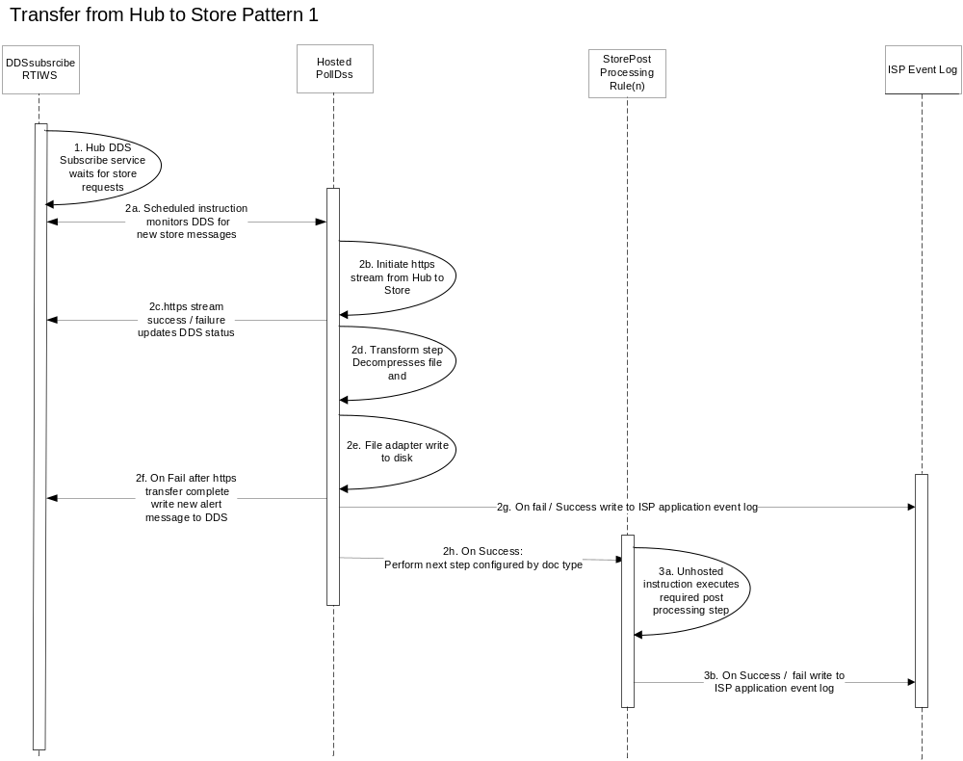

Normal Sequence Diagram Walkthrough
Normal Sequence # | Event | Component Invoked | Output | Alternate flow sequence#
1. | DDS subscribe web service exposes DDS database messages to store agents polling for new events | DDSsubcribeWS | New DDS message Broadcast
2a. | Scheduled instruction on the RTI store agent polls DDS looking for new messages | StorePollDDS | https stream initiated
2b. | DDSadapter streams file from Hub to Store | StorePollDDS | File transferred
2c. | Store Agent will report success / fail back to DDS upon completion or failure of the https | StorePollDDS | Update to DDS
2d. | StorePollDDS transform step uncompress file at store | StorePollDDS | Transform step
2e. | StorePollDDS file adapter renames and writes file to disk  Note: If rename step complicated, may require post processing instruction at step 3a) | StorePollDDS | File adapter step
2f. | DSS adapter calls back DDS insert a new error message to DDS. Will be picked up by a DDS Alert monitor | StorePollDDS | Insert DDS
2g. | On fail write message on store ISP application event log | StorePollDDS | On success / on Fail
2h. | On Success write to store ISP application event log / or call post processing instruction | StorePollDDS | Complete / Post Process
3a. | Unhosted receive executes required post processing step at store:  (Unzip, rename, respond message) | SourceToHub  Pattern(n)RTI | Call SFTP adapter
3b. | On success or failure call windows event log adapter to write status to store ISP event log | SourceToHub  Pattern(n)RTI | Complete

Alternate Flow

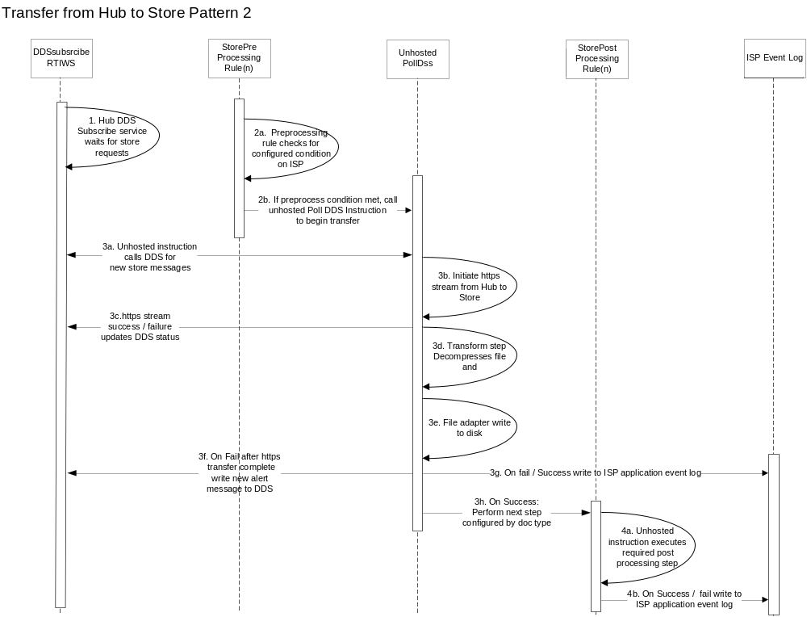

Normal Sequence # | Event | Component Invoked | Output | Alternate flow sequence#
1. | DDS subscribe web service exposes DDS database messages to store agents polling for new events | DDSsubscribeWS | New DDS message Broadcast
2a. | RTI instruction with Preprocessing rule runs on a schedule to execute a task on the ISP | StorePreProcessingRule(n) | Pre processing step completed
2b. | Scheduled instruction calls unhosted Poll DSS to initiate pull from Hub | StorePreProcessingRule(n) | UnHostedPollDDS initiated
3a. | Unhosted instruction on the RTI store agent polls DDS looking for new messages | StorePollDDS | https stream initiated
3b. | DDSadapter streams file from Hub to Store | StorePollDDS | File transferred
3c. | Store Agent will report success / fail back to DDS upon completion or failure of the https process | StorePollDDS | Update to DDS
3d. | StorePollDDS transform step uncompress file at store | StorePollDDS | Transform step
3e. | StorePollDDS file adapter renames and writes file to disk  Note: If rename step complicated, may require post processing instruction at step 3a) | StorePollDDS | File adapter step
3f. | DSS adapter calls back DDS insert a new error message to DDS. Will be picked up by a DDS Alert monitor | StorePollDDS | Insert DDS
3g. | On fail write message on store ISP application event log | StorePollDDS | On success / on Fail
3h. | On Success write to store ISP application event log / or call post processing instruction | StorePollDDS | Complete / Post Process
4a. | Unhosted receive executes required post processing step at store:  (Unzip, rename, respond message) | SourceToHub  Pattern(n)RTI | Call SFTP adapter
4b. | On success or failure call windows event log adapter to write status to store ISP event log | SourceToHub  Pattern(n)RTI | Complete

RTI Components

RTI Web Services

WEB Service Name | URL | DETAILS
DDSsubscribeWS | XX | Incoming DDS web service

RTI Instructions
The following RTI instruction templates will be required for the Hub to Store Service:
Instruction Name | Type | Details
HostedPollDDS | Scheduled | Hosted Instruction to Poll DDS
StorePreProcessRule1 | Scheduled | Scheduled instruction runs a pre process to ensure that no file exists in destination directory before initiating a new transfer
UnHostedPollDDS | Unhosted Receive | UnHosted Instruction to Poll DDS when initiated by a preprocessing rule
StorePost  ProcesingRule1 | Unhosted Receive | Unzip archive to a specific directory after transfer to ISP complete
StorePost  ProcesingRule2 | Unhosted Receive | Rename file at destination if rule too complex for base file adapter functionality
StorePost  ProcesingRule3 | Unhosted Receive | Respond to DDS with file complete message if required for message correlation

Operations

Restart/Recover conditions
Failure Point | Description | Resubmit Functionality | Process Type | Guiding Principle | Support Procedure | Frequency
HostedPollDDS /  UnhostedPollDDS | Fails to connect to DDS WS | Error occurs and Retry | N/A | Infrastructure Issue | ? | Low
HostedPollDDS /  UnhostedPollDDS | RTI fails to transfer file | Error occurs and Retry / restart transmission | Https / Transfer | Infrastructure Issue | ? | Low
HostedPollDDS /  UnhostedPollDDS | RTI fails to uncompress at store | None update DDS with fail | Uncompress | Store Issue | ? | Low
HostedPollDDS /  UnhostedPollDDS | RTI fails to Write to disk | None update DDS with fail | Disk write | Store Issue | ? | Low
StorePost  ProcessingRule(n) | RTI fails to complete post processing step | None update store ISP event log with error code. | Event log | Store Issue | ? | Low
StorePre  ProcessingRule(n) | RTI fails to complete post processing step | None update store ISP event log with error code. | Event log | Store Issue | ? | Low

Assumptions
ID | Description
1 | All the attributes defined in the message body of the invocation message should be treated as overrides for any default value defined in the RTI file transfer metadata.
2 | StorePostProcessingRule(n)RTI instruction is a variable component the specific instructions required will be determined by the details interface configuration sheets
3 | General Alert and Error handling of events in the DDS database will are included in the Solution Architecture Technical Design
4 | Processing errors which occur at the store will be written to the Store’s ISP event application log

